in partnership with
MAW Education – Courses, Webinars and Books

On - line Teaching Training Accredited Course based on Multiple Intelligences Theory
(Reduced rates if booked through TAP)
MAW On-line Academy (thinkific.com)
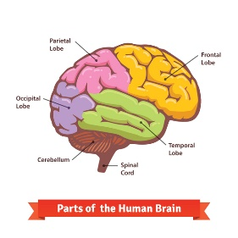
Module 1 - £87.25
Improving Teaching Skills - Module 1 - An Introduction to Famous Educationalists and Howard Gardner's Multiple Intelligences (thinkific.com)
Module 2 - £172.50
Improving Teaching Skills - Module 2 - The learning environment; How students learn; Teaching skills; Lesson planning; Assessment. (thinkific.com)

Module 3 - £87.25
Improving Teaching Skills - Module 3 - An Introduction to The Leadership Team and Parents as Partners. (thinkific.com)
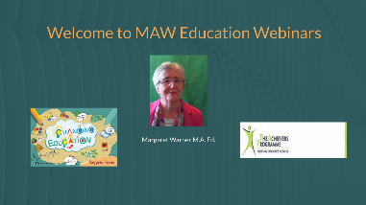
Multiple Intelligences Webinars - Summary Video above (Free from TAP)
https://my.visme.co/view/x4eo8gnn-pmjlj046x9ov2z39
Three-Session Interactive Webinars for Teachers (90 mins each session) – Book through TAP

Full length book published in India by Good Luck Publisher – Changing Education
All Books - Good Luck Publishers
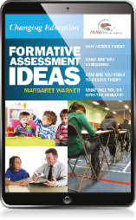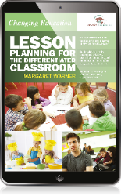
Kindle version of booklets on Assessment and Lesson Planning - £8.95
Amazon.com: Margaret Warner: Books, Biography, Blog, Audiobooks, Kindle
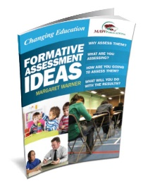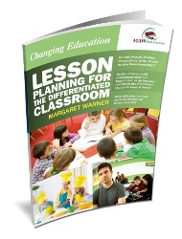
Assessment and Lesson Planning booklets – for teachers not attending the webinar - $12
Multiple Intelligence Books | Oxford, Oxfordshire (mi-education.com)
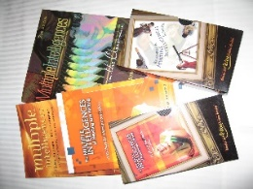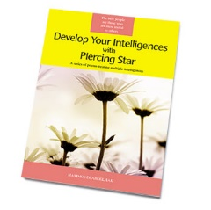
Hard Backed Books on Multiple Intelligences – individually priced
Books | Product categories | Multiple Intelligences (multiple-intelligences.com)

